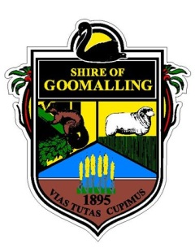
Shire of Goomalling

Application Form

Cat Registration
I_______________________________________________________________________(Owner/Agent)
Of______________________________________________________________________(Address)
Name of Cat
Age | Years |  | Months
Sex | Male |  | Female
Sterilised | YES |  | NO
Microchip Number
Colour/Distinguishing marks
Breed/Kind of Cat
Concession Number if applicable
Owners Full Name
Postal Address
Premises where Cat will ordinarily kept
Home Number
Mobile Number
Email Address
Term of Registration | 1 Year |  | 3 Years |  | Life
Signature: _________________________________________Date:_________________________________

FOR OFFICE USE ONLY
Fees Payable
Unsterilised Cat 1 Year $50.00 3 Years $120.00 Life $250.00
Sterilised Cat 1 Year $20.00 3 Years $42.50 Life $100.00
Pensioners ½ Registration Fee

This Registration is Valid until __/__/__ Tag Number: ___________________________________

Date of Issue: ___/___/___ signature of registration officer: ______________________

Administration Centre T: (08)96291101
32 Quinlan Street (PO Box 118) F: (08) 96291017
Goomalling WA 6460 E: goshire@goomalling.wa.gov.au

