*This charter sets out our commitment to providing excellent customer service, as we aim to deliver a welcoming, consistent and positive customer experience on every interaction.*

*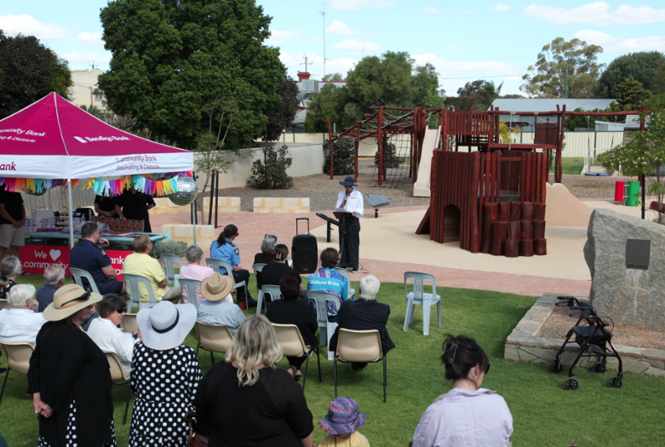Council is committed to providing our customers with a reliable and responsive service. To improve services, Council has put into place organisation-wide Service Standards to advise customers about the time frames by which we will endeavour to respond to your request, and the levels of service you should expect form us.*

**

**TELL US WHAT YOU THINK**

We welcome your comments, compliments and information on how e can serve you better. You can do this by contacting our Customer Service Staff on 08 9629 1101, or by emailing us at goshire@goomalling.wa.gov.au.

**OUR SERVICE COMMITMENT TO YOU**…

* Be friendly, efficient, and consistent on every occasion
* Handle your enquiry with confidentiality and respect
* Resolve your enquiry at first contact where we can, or explain how your matter will be progressed and who is responsible
* Provide information, which is timely, accurate and reliable
* Provide you with a reference number and time frame for your service request.
* Continually review and improve our services to you

**WHAT DO WE ASK FROM YOU?**

* Treat our staff with courtesy and respect
* Provide information that is timely, accurate and complete to assist us in meeting our service levels and your expectations
* Be open and honest in your dealings with us
* Provide us with honest and constructive feedback to help us improve service delivery

**WHEN YOU VISIT, WE WILL…**

* Promptly greet you at the customer contact counter
* Provide directions for your appointment
* Process your transactions efficiently with a smile

**WHEN YOU TELPHONE US, WE WILL…**

* Strive to answer your call within 5 minutes
* Greet you courteously and introduce ourselves by name
* Strive to have your enquiry resolved directly without unnecessary transfers
* Return phone calls an messages at the first opportunity

**WHEN YOU WRITE, WE WILL…**

* Acknowledge your correspondence within one (1) business day, and reply within ten (10) working days
* For complex enquiries, you will be advised of the expected time required to finalise your request
* Ensure we communicate with you using easy to understand language

**WITH WEBSITE AND SOCIAL MEDIA, WE WILL…**

* Ensure regular monitoring of social media and respond if action is necessary with two (2) working days
* Continuously review our website to ensure it is easy to use, with clear navigation and content so that you can quickly find the information you need