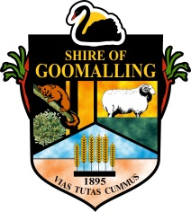
Shire of Goomalling
32 Quinlan Street (PO Box 118)
GOOMALLING WA 6460
P: 08 9629 1101 | F: 08 9629 1017 | E: goshire@goomalling.wa.gov.au

MEDIA RELEASE
BMX POCKET PARK OFFICIALLY OPENED AND FREESTYLE NOW SHOWCASE MAD SKILLS
A warm spring morning to welcome the new day and official open the pocket park.

Hon Mia Davies Minister for Sport & Recreation, Water and our local member eloquently congratulated Council for its commitment to the youth of Goomalling who will be future leaders of our community. Ms Davies expressed more communities are investing in ‘unstructured’ recreation, developing life skills through the natural order of play. The track demands that young people learn to share, to be leaders empathetic of smaller riders, to fail and try again all extremely positive learnt behaviour.

Melissa Price expressed her congratulations to Council for expanding on the facilities available for young people and its success in Stronger Communities Programme Youth Round part of the Australian Government’s Stronger Regions initiative. Goomalling was one of ten successful community projects in the Durack region and the first facility to be opened 13 November 2016.

Once the formalities were over sausage sizzles and cool drinks were available courtesy of Goomalling & Districts Community Bank®. Thank you to staff, board members and Regional Manager Martyn Neville for attending.

Freestyle Now conducted a BMX beginners workshop, competitions and stunt show funded by the Department of Local Government and Communities youth friendly planning initiative. Congratulations to Connor O’Garr for highest jump and Finley Simpson quickest in time trial. Everyone displayed great aptitude and endeavour, sharing bikes and cheering each other on.

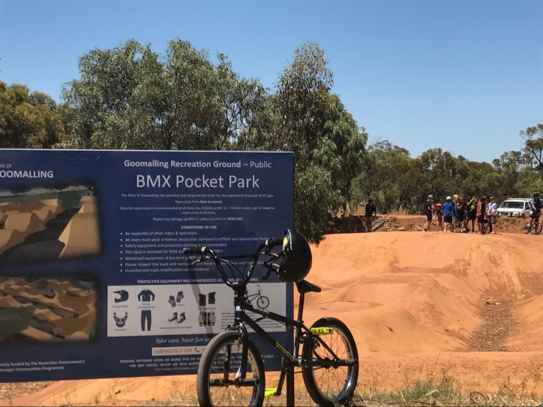
Whilst the pocket park is officially open there are still a few minor works to be carried out including cleaning up the site and installing the shelters.
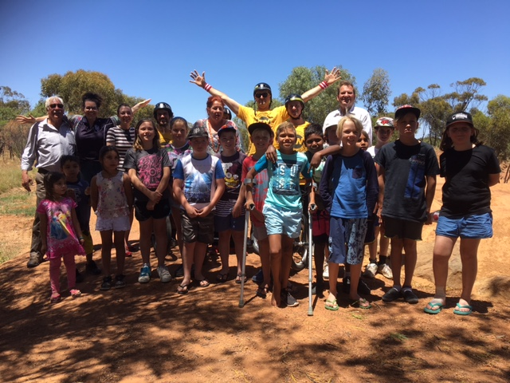
Media Contact Tahnee Bird, Community Development Officer
Authorising Officer Clem Kerp, Chief Executive Officer
Date 23 November 2016

