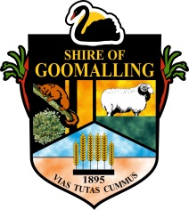
Shire of Goomalling
32 Quinlan Street (PO Box 118)
GOOMALLING WA 6460
P: 08 9629 1101 | F: 08 9629 1017 | E: goshire@goomalling.wa.gov.au

MEDIA RELEASE
CACTUS - WANTED DEAD OR ALIVE
Western Australia is host to many cactus varieties that pose a threat to agriculture and the environment.
The Department of Agriculture and Food is bringing attention to this pest by marking ‘cactus month’ this November – urging local landholders and communities to report infestations.
A range of cacti are now classified as declared plants in Western Australia under the Biosecurity and Agriculture Management Act 2007(BAMA).
This means that if these plants are on your property, you are required by law to manage them according to their categorisation.
Typically, problem plants that are not present in WA are declared under the prevention category, which means they are prohibited from entering the state. Declared species that are present in WA are assigned different categories such as eradication or control.
Of 27 species of opuntioid cacti species, 23 are present in WA. If you have these on your property, you must take action to control or eradicate them.
WA is in a fairly unique position when it comes to these cacti. We have a relatively low number of known infestations and the total area infested is also low, compared to other states. In NSW for example, Hudson pear cactus infests 60,000 ha in the Lightning Ridge area. Hudson pear has been found in WA but has not yet reached the proportions as it has elsewhere.
This means WA has a good opportunity to prevent further spread and even eradicate many infestations of opuntia.
To achieve this we first need to know the extent of their distribution and this is where everyone can play a part.
In Shire of Goomalling we know of approximately 90ha of Opuntia cacti including Opuntia tomentosa “Velvet Tree Pear”.
There are a range of trials using a variety of techniques currently underway to manage these infestations. To support these control efforts it is vital that all infestations, no matter how big or small are reported and recorded.

If you are unsure whether or not you have a declared plant or animal on your property that you are required to manage, visit the Department of Agriculture and Food (DAFWA) website. You will find information on all declared pests in WA including images for identification and the most effective control techniques.

If a new species of invasive cacti can be detected while the population is small, eradication is often feasible. There are numerous examples of successful eradication.
Unfortunately, many infestations go un-noticed and are not reported. Don’t let this happen in your neighbourhood; get it before it gets hold on your property.
Report large weedy infestations of Opuntioid cactus to:
- Pest and Disease Information Service (PaDIS) 1800 084 881
- MyWeedWatcher smartphone and tablet application agric.wa.gov.au/weed-surveillance
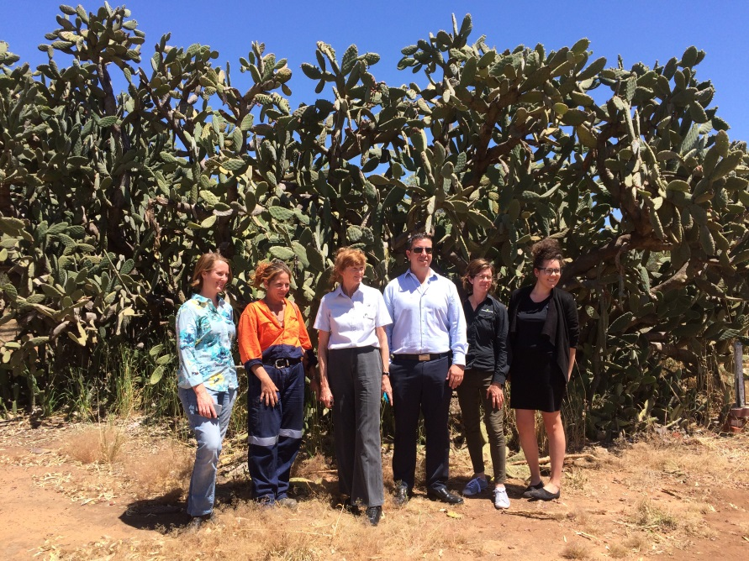
- Online reporting tool agric.wa.gov.au/myweedwatcher
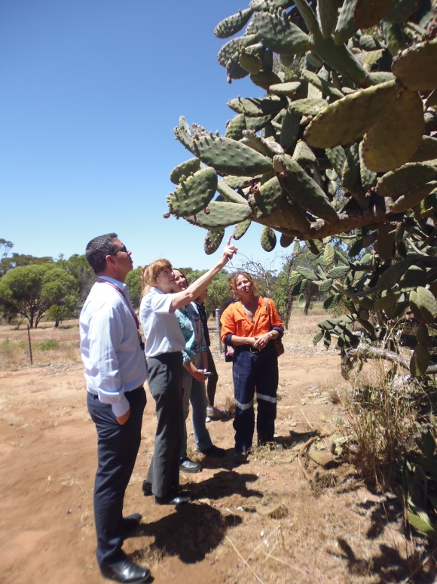
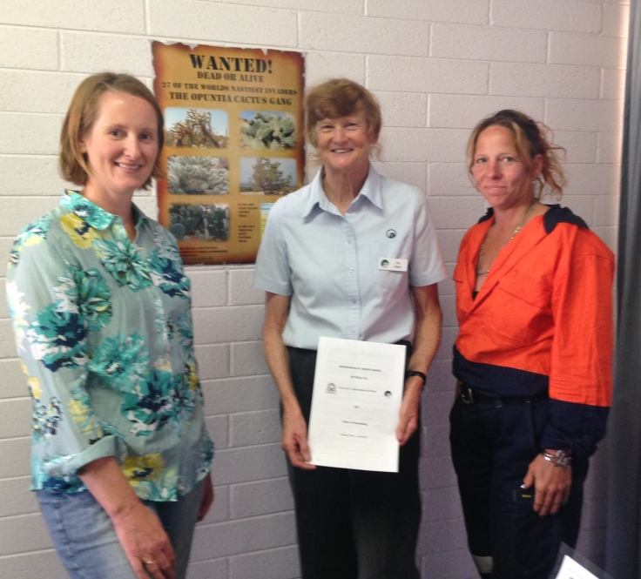
Shire of Goomalling received $20,000 through the Department of Agriculture and Food WA to identify vector of spread, carry out trials for effective eradication and build community capacity.
Sacred Heart Catholic School has been pivotal in identifying a number of infestations throughout the shire and will continue to partner throughout the project.
Picture 1 (Top left): Cr Christie Kingston, Kay Bailey Department of Agriculture & Food WA, Jodi Iles, Project Officer – DAFWA hand over the signed funding agreement.
Picture 2 (top right): Project Partners – Cr Kingston, Jodi Iles, Kay Bailey, Steve Miranda - Sacred Heart Catholic School, Julie Murphy – Greening Australia and Tahnee Bird – Project Manager.
Picture 3 (left): Inspecting the infestation, new germinated and fruiting.

PLEASE DO NOT DISPOSE OF CACTUS AT THE LOCAL TIP – THE CACTUS WILL REGERMINATE AND SPREAD. THE SHIRE HAS A SPECIFIC PIT FOR DISPOSAL, PLEASE CALL 08 9629 1101 TO ARRANGE DUMPING.

Media Contact Tahnee Bird, Community Development Officer
Authorising Officer Clem Kerp, Chief Executive Officer
Date 22 November 2016

