## Easter Closure

Closed: 12 noon on Thursday 28 March 2024

Reopen: 08.30 am Tuesday 02 April 2024

Goomalling Waste Facility – Closed Good Friday

## Anzac Day Closure

Closed: Thursday 25 April 2024

Closed: Friday 26 April 2024

Reopen: 08.30 am Monday 29 April 2024

Goomalling Waste Facility – Normal Trading

**Refuse Site**

Closed: Good Friday, 29 March 2024

**Medical Surgery**

Closed on Public Holidays

**Swimming Pool**

The pool will be closing for the 2023/24 season at 6.00pm on Wednesday 27 March 2024.

**Avon Waste Rubbish Collection**

NOT IMPACTED and will continue as normal

## Dog & Cat Registrations

Cat and dog registrations expire on 31st of October each year.

## Heavy Vehicle Permits

Permits are required for vehicles over 19m long, traversing on our local roads that are contained within the Main Roads WA RAV Network Permit Plan. Permits are valid for 12 months. Please check the validity of your permits and renew them before the busy harvest period if required.

## Christ

Contents

**No table of contents entries found.**

## mas Closures

**Administration Office**

Close: Friday, 22 December, 12.30 pm

Open: Tuesday, 02 January, 8.45am

**Road Crew**

Close: Friday, 22 December 2023

Open: Tuesday, 02 January 2024

**Town Maintenance, Parks & Gardens**

Close: Friday, 22 December 2023

Open: Tuesday, 02 January 2024

**Refuse Site**

Close: Christmas Day, Boxing Day and New Years Day

**Medical Surgery**

Close: Friday, 22 December 2023 1.00pm

Open: Tuesday, 02 January 2023

**Swimming Pool**

Close: Christmas Day, Monday 25 December 2023, Boxing Day, Tuesday 26 December 2023.

Open: New Years Day, Monday 01 January 2024 between 4.00pm and 6.00pm – No lap swimming available on ALL public holidays.

**Avon Waste Rubbish Collection**

NOT IMPACTED and will continue as normal

## Dog & Cat Registrations

Cat and dog registrations expire on 31st of October each year. If your pet’s registration is due to expire this year, you can expect your renewal notice in the mail later this month.

## Heavy Vehicle Permits

Permits are required for vehicles over 19m long, traversing on our local roads that are contained within the Main Roads WA RAV Network Permit Plan. Permits are valid for 12 months. Please check the validity of your permits and renew them before the busy harvest period if required.

## Christmas Closures

**Administration Office**

Close: Friday, 22 December, 12.30 pm

Open: Tuesday, 02 January, 8.45am

**Road Crew**

Close: Friday, 22 December 2023

Open: Tuesday, 02 January 2024

**Town Maintenance, Parks & Gardens**

Close: Friday, 22 December 2023

Open: Tuesday, 02 January 2024

Refuse Si

Contents

Christmas Closures 1

Shire

Heavy Vehicle Permits 1

Shire President’s message 2

Staff movements 3

Ranger Services **Error! Bookmark not defined.**

Community Projects and Services 6

Works department updates 7

Road Works 7

Road Maintenance 8

Parks & Gardens 8

Plant **Error! Bookmark not defined.**

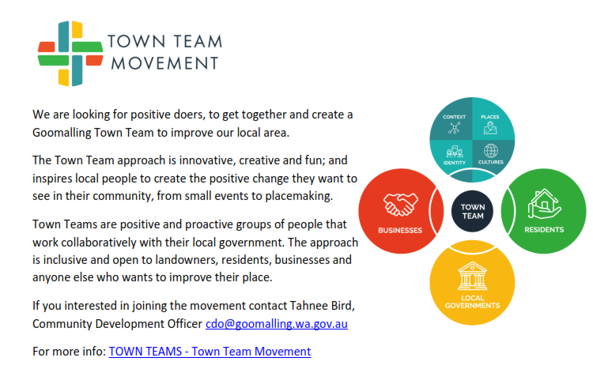 **Error! Bookmark not defined.**

**Error! Bookmark not defined.**

Dates for your diary 16

Close: Friday, 22 December 2023 1.00pm

Open: Tuesday, 02 January 2023

**Swimming Pool**

Close: Christmas Day, Monday 25 December 2023, Boxing Day, Tuesday 26 December 2023.

Open: New Years Day, Monday 01 January 2024 between 4.00pm and 6.00pm – No lap swimming available on ALL public holidays.

**Avon Waste Rubbish Collection**

NOT IMPACTED and will continue as normal

## Dog & Cat Registrations

Cat and dog registrations expire on 31st of October each year. If your pet’s registration is due to expire this year, you can expect your renewal notice in the mail later this month.

## Heavy Vehicle Permits

Permits are required for vehicles over 19m long, traversing on our local roads that are contained within the Main Roads WA RAV Network Permit Plan. Permits are valid for 12 months. Please check the validity of your permits and renew them before the busy harvest period if required.

## Christ

Contents

**No table of contents entries found.**

## mas Closures

**Administration Office**

Close: Friday, 22 December, 12.30 pm

Open: Tuesday, 02 January, 8.45am

**Road Crew**

Close: Friday, 22 December 2023

Open: Tuesday, 02 January 2024

**Town Maintenance, Parks & Gardens**

Close: Friday, 22 December 2023

Open: Tuesday, 02 January 2024

**Refuse Site**

Close: Christmas Day, Boxing Day and New Years Day

**Medical Surgery**

Close: Friday, 22 December 2023 1.00pm

Open: Tuesday, 02 January 2023

**Swimming Pool**

Close: Christmas Day, Monday 25 December 2023, Boxing Day, Tuesday 26 December 2023.

Open: New Years Day, Monday 01 January 2024 between 4.00pm and 6.00pm – No lap swimming available on ALL public holidays.

**Avon Waste Rubbish Collection**

NOT IMPACTED and will continue as normal

## Dog & Cat Registrations

Cat and dog registrations expire on 31st of October each year. If your pet’s registration is due to expire this year, you can expect your renewal notice in the mail later this month.

## Heavy Vehicle Permits

Permits are required for vehicles over 19m long, traversing on our local roads that are contained within the Main Roads WA RAV Network Permit Plan. Permits are valid for 12 months. Please check the validity of your permits and renew them before the busy harvest period if required.

## Christmas Closures

**Administration Office**

Close: Friday, 22 December, 12.30 pm

Open: Tuesday, 02 January,uary 2024

**Town Maintenance, Parks & Gardens**

Close: Friday, 22 December 2023

Open: Tuesday, 02 January 2024

**Refuse Site**

Close: Christmas Day, Boxing Day and New Years Day

**Medical Surgery**

Close: Friday, 22 December 2023 1.00pm

Open: Tuesday, 02 January 2023

**Swimming Pool**

Close: Christmas Day, Monday 25 December 2023, Boxing Day, Tuesday 26 December 2023.

Open: New Years Day, Monday 01 January 2024 between 4.00pm and 6.00pm – No lap swimming available on ALL public holidays.

**Avon Waste Rubbish Collection**

NOT IMPACTED and will continue as normal

## Dog & Cat Registrations

Cat and dog registrations expire on 31st of October each year. If your pet’s registration is due to expire this year, you can expect your renewal notice in the mail later this month.

## Heavy Vehicle Permits

Permits are required for vehicles over 19m long, traversing on our local roads that are contained within the Main Roads WA RAV Network Permit Plan. Permits are valid for 12 months. Please check the validity of your permits and renew them before the busy harvest period if required.

## Christ

Contents

**No table of contents entries found.**

## mas Closures

**Administration Office**

Close: Friday, 22 December, 12.30 pm

Open: Tuesday, 02 January, 8.45am

**Road Crew**

Close: Friday, 22 December 2023

Open: Tuesday, 02 January 2024

**Town Maintenance, Parks & Gardens**

Close: Friday, 22 December 2023

Open: Tuesday, 02 January 2024

**Refuse Site**

Close: Christmas Day, Boxing Day and New Years Day

**Medical Surgery**

Close: Friday, 22 December 2023 1.00pm

Open: Tuesday, 02 January 2023

**Swimming Pool**

Close: Christmas Day, Monday 25 December 2023, Boxing Day, Tuesday 26 December 2023.

Open: New Years Day, Monday 01 January 2024 between 4.00pm and 6.00pm – No lap swimming available on ALL public holidays.

**Avon Waste Rubbish Collection**

NOT IMPACTED and will continue as normal

## Dog & Cat Registrations

Cat and dog registrations expire on 31st of October each year. If your pet’s registration is due to expire this year, you can expect your renewal notice in the mail later this month.

## Heavy Vehicle Permits

Permits are required for vehicles over 19m long, traversing on our local roads that are contained within the Main Roads WA RAV Network Permit Plan. Permits are valid for 12 months. Please check the validity of your permits and renew them before the busy harvest period if required.

## Christmas Closures

**Administration Office**

Close: Friday, 22 December, 12.30 pm

Open: Tuesday, 02 January, 8.45am

**Road Crew**

Close: Friday, 22 December 2023

Open: Tuesday, 02 January 2024

**Town Maintenance, Parks & Gardens**

Close: Friday, 22 December 2023

Open: Tuesday, 02 January 2024

Refuse Si

Contents

Christmas Closures 1

Shire

Heavy Vehicle Permits 1

Shire President’s message 2

Staff movements 3

Ranger Services **Error! Bookmark not defined.**

Community Projects and Services 6

Works department updates 7

Road Works 7

Road Maintenance 8

Parks & Gardens 8

Plant **Error! Bookmark not defined.**

 **Error! Bookmark not defined.**

**Error! Bookmark not defined.**

Dates for your diary 16

Close: Friday, 22 December 2023 1.00pm

Open: Tuesday, 02 January 2023

**Swimming Pool**

Close: Christmas Day, Monday 25 December 2023, Boxing Day, Tuesday 26 December 2023.

Open: New Years Day, Monday 01 January 2024 between 4.00pm and 6.00pm – No lap swimming available on ALL public holidays.

**Avon Waste Rubbish Collection**

NOT IMPACTED and will continue as normal

## Dog & Cat Registrations

Cat and dog registrations expire on 31st of October each year. If your pet’s registration is due to expire this year, you can expect your renewal notice in the mail later this month.

## Heavy Vehicle Permits

Permits are required for vehicles over 19m long, traversing on our local roads that are contained within the Main Roads WA RAV Network Permit Plan. Permits are valid for 12 months. Please check the validity of your permits and renew them before the busy harvest period if required.

## Christ

Contents

**No table of contents entries found.**

## mas Closures

**Administration Office**

Close: Friday, 22 December, 12.30 pm

Open: Tuesday, 02 January, 8.45am

**Road Crew**

Close: Friday, 22 December 2023

Open: Tuesday, 02 January 2024

**Town Maintenance, Parks & Gardens**

Close: Friday, 22 December 2023

Open: Tuesday, 02 January 2024

**Refuse Site**

Close: Christmas Day, Boxing Day and New Years Day

**Medical Surgery**

Close: Friday, 22 December 2023 1.00pm

Open: Tuesday, 02 January 2023

**Swimming Pool**

Close: Christmas Day, Monday 25 December 2023, Boxing Day, Tuesday 26 December 2023.

Open: New Years Day, Monday 01 January 2024 between 4.00pm and 6.00pm – No lap swimming available on ALL public holidays.

**Avon Waste Rubbish Collection**

NOT IMPACTED and will continue as normal

## Dog & Cat Registrations

Cat and dog registrations expire on 31st of October each year. If your pet’s registration is due to expire this year, you can expect your renewal notice in the mail later this month.

## Heavy Vehicle Permits

Permits are required for vehicles over 19m long, traversing on our local roads that are contained within the Main Roads WA RAV Network Permit Plan. Permits are valid for 12 months. Please check the validity of your permits and renew them before the busy harvest period if required.

**In Flanders fields the poppies blow**

**Between the crosses, row on row,**

**That mark our place:**

## Contents

Easter/Anzac Day Closures 1

Shire Presidents Message 2

Your Council 2

Council Meeting Dates 2024 3

Staff Movements 3

Animal Matters 4

Poultry Guidelines 4 Corella Control Survey 5

Dogs and Cats 5

Control of Dogs and Cats 5

Council Meeting Dates 2024 5

Community Projects and Services 5

Anstey Park 5

Football Club Night Lights 6

AROC – Workforce Survey 6

Driving Test Dates 7

Works Update 7

Plant 7

Roadworks 7 Road Maintenance 8

Parks and Gardens 8 Reporting Issues 8

Refuse Disposal Facility 9

Goomalling Community Garden 10

Goomalling Historical Society 10

Anzac Services 14

Dates for your diary 16

# Shire President’s Message

Autumn is now with us and with this come the Restricted Burning Season, this is a timely reminder to obtain your permits and remember even if you have a permit if there is a High Fire Danger forecast No Burning is permitted.

The Anstey Park play ground is now completed and is being utilised daily which is fantastic to see. It is an amazing little playground and looks fabulous in our main street.

Several new businesses are on the up, and we welcome them all and wish them well and it is fair to say our little town is a buzz with lots of activity.

Great to see the girls in the office take upon themselves to start the Possum Post, so if you have anything to advertise, please let them know, and timely named with the sighting of our own little possum.

Unfortunately, we have lost some road funding so our budget will again be pushed to its limits. We have been lucky enough to secure some grant funding for sports lighting projects, the Football Club project is well under way with the installation of new lights, and the Bowling Club will commence work for their new lights in the near future. So, Goomalling is looking pretty good at the moment.

Lastly Councillors and I would like to thank Peter Bentley for his commitment to Goomalling Shire over the past 5 years in the position of Chief Executive Officer. It has been a pleasure to work with Peter, we wish him well in his retirement.

We welcome new Chief Executive Officer, Sam Bryce, to our community and look forward to working with him.

**Cr Julie Chester**

**Shire President**



# 

# Council Meeting Dates 2024

# Staff Movements

**Administration**

Our existing Chief Executive Officer, Peter Bentley will be taking long service leave from 01 April 2024 and will retire at the completion of his leave period.

Mr Sam Bryce has been appointed to the role of Acting Chief Executive Officer in the interim period and will be appointed to the substantive role of Chief Executive Officer following the completion of Peter’s leave.

Sam comes to Goomalling from the Shire of Katanning where he currently holds the position of Executive Manager Infrastructure and Assets and has done so since February 2021. Sam has a wealth of experience in asset management gained most recently through Local Government while working with Cities of Stirling, Fremantle and Wanneroo between 2011 and 2021 and previously in various roles over many years.

**Works**

Mark Williamson has joined the works team in the position of Gardener/Town Maintenance.

Mark and wife, Judy have relocated from Tom Price.

**Caravan Park**

Welcome to Ricky and Liz who have taken up the joint role of Goomalling Caravan Park Manager.

# Animal Matters…

**Guidelines for Keeping of Poultry in Residential Zoned Land**

Due to the noise issues surrounding roosters and peafowl, the keeping of these birds is carefully controlled so as to minimize disturbance.

On land that is zoned residential, it is not possible to keep a rooster, turkey, goose or gander, any game bird or a peafowl without the resident being granted an exemption by the Shire of Goomalling to do so.

The property owner must then comply with any conditions that the Shire of Goomalling sees appropriate as part of the exemption approval.

If you are making application as a result of a complaint associated with the keeping of roosters you will need to lodge the application demonstrating that you have satisfied the requirements listed above and any other conditions that have been deemed appropriate by the Shire.

**Extract - Health Local Law**

**Conditions for Keeping Poultry in Limited Numbers**

5.4.3

A person who keeps poultry or permits poultry to be kept shall ensure that –

(a) no poultry is able to approach within 9 metres of a dwelling house, public building or premises where people are employed or where food is stored, prepared, manufactured or sold;

(b) all poultry is kept in a properly constructed and securely fastened structure or enclosure;

(c) the structure is in a yard having an otherwise unobstructed area of at least 30 square metres;

(d) no poultry are able to approach within 9 metres of a street other than a right of way unless, in the case of land at the junction of two or more streets, Council has approved a lesser distance;

(e) no poultry is able to approach within 1.2 metres of any side or rear boundary of the premises; and

(f) all enclosures or cages within which poultry are kept shall be maintained at all times in a clean condition and shall be disinfected or otherwise dealt with in a way as directed by an Environmental Health Officer.

**Roosters, Geese, Turkeys, Peafowl's and Game birds**

5.4.4

(1) An occupier of premises within a townsite, shall not without the written approval of the Council, keep or permit to be kept on those premises, any one or more of the following fowl –

(a) a rooster;

(b) a goose or gander;

(c) a turkey;

(d) a peacock or peahen; and

(e) a game bird (includes emus and ostriches).

(2) The Council may upon written application, grant approval with or without conditions to the owner or occupier of premises to keep any one or more birds as specified in subsection (1).

(3) A person who has been granted approval under this Section to keep a bird may keep the bird on the premises only while he is the occupier thereof. (4) The Council may revoke an approval granted under this Section if it is of the opinion that the keeping of the birds specified in the approval is causing a nuisance or is injurious, offensive or dangerous to health.

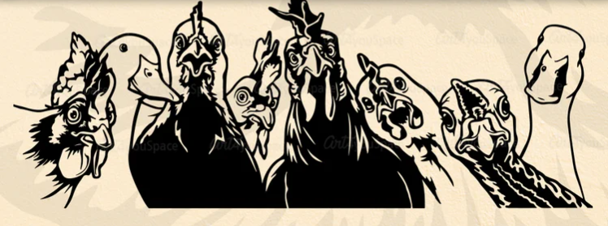

**Corella Control Survey**

The Avon Regional Organisation of Councils (AROC) is working with Wheatbelt NRM, CBH and other Councils to investigate ways to control the Corella problem which has persisted and grown in many parts of the Wheatbelt for some years now.

In the initial stages the AROC commissioned a study which identified the scale of the problem and listed a number of potential remedies. The study was completed some two (2) years ago and during that time we have been trying to attract a wider consortium of participants to contribute to the potential control of these pest birds. Wheatbelt NRM has appointed Jacquie Lucas to coordinate the wider project.

To follow up on the work already done, Jacquie has created a survey which gives the participants the opportunity to identify location, bird numbers and damage done of and by the Corellas. The attached QR code takes you directly to the survey which will ask where, how many, what they were doing and give you the ability to attach photos.

The survey is to give updated data to the coordinator so that a wider range of control methods can be investigated with the State Government and the other stakeholders. I encourage you to use the survey as without the data we will struggle to gain the State’s support for more effective control measures.

**Use the barcode to get started:**



**Dogs and Cats**

All dogs need to be registered and micro-chipped from the age of three (3) months. When your dog is micro-chipped you need to advise the Shire of the number and provide a copy of the documentation if possible.

All domestic cats six (6) months of age must be registered with your local government, and must be micro-chipped and desexed. When registering your cat, make sure you have their micro-chip and sterilisation certificates.

To help identify an owned dog or cat, it needs to wear a collar and registration tag.

For more information on your responsibilities as a dog/cat owner refer to Dog Act 1976, Cat Act 2011 and Local Laws.

Penalties **will** apply for identified breaches.

Contact details for Ranger:

Rural Ranger Services

0412 561 828

Irene Ryan



# Disability Access and Inclusion Plan Review

The Western Australian Disability Service Act (1993) requires Local Government authorities to develop and implement disability service plans to ensure that people with disabilities, like other members of the community, can access services provided by public authorities in Western Australia.

As required under the Act and to improve access for people with disabilities, the Shire of Goomalling is undertaking a review of its Disability Access and Inclusion Plan 2018-2023 (DAIP).

The Shire is committed to achieving the seven (7) standards of its Disability Access and Inclusion Plan which are as follows:

1. Provide a means of ensuring that people with disability have the same opportunities as others to access the services of, and any event organised by the Shire of Goomalling.
2. Provide a means of ensuring that people with disability have the same opportunities as others to access buildings and other facilities of the Shire of Goomalling.
3. Provide a means of ensuring that people with disability receive information for the Shire in a format that will enable them to access information as readily as others are able to.
4. Provide a means of ensuring that people with a disability receive the same level and quality of service form the staff of the Shire of Goomalling as other people.
5. Provide a means of ensuring that people with disability have the same opportunities as others to make complaints to the Shire of Goomalling.
6. Provide a means of ensuring that people with a disability have the same opportunities as others to participate in ay public consultation with the Shire of Goomalling.
7. People with disability have the same opportunities to obtain and maintain employment with the Shire of Goomalling.

We are interested to hear your thoughts regarding how the Shire can improve access to its services, facilities and information. Please submit your comments by 02 April 2024

Comments will be received by the following means:

Post: Shire of Goomalling, PO Box 118, GOOMALLING WA 6460

Email: goshire@goomalling.wa.gov.au

# Community Projects and Services

# Anstey Park Opening

This project is now completed and was opened to the public in February 2024.

It is disappointing to note that there have been a number of instances of vandalism at Anstey Park since reopening to the public including breaking of play elements, trashing of the toilet, feature rock throwing and breaking and damage to fencing.   It appears that one of those responsible may have cut themselves on the broken glass.

In addition, issues have arisen with litter (coffee cups) and dog excrement not being disposed of by park users and dog owners.

While the damage and cleanup is costly and disappointing, it is also a really poor outcome for the youth of the town and the wider community as the park was developed from their feedback for us to provide better facilities for our youth.

Unfortunately, we are now likely to install CCTV monitoring at the park and if the damage continues, we will consider fencing off the park and having it open for limited times during the week.   We will also consider prosecuting anyone who is caught on camera vandalising the facility.

PLEASE:   Pick up your rubbish, scoop the poop and don’t throw rocks!

**Sports Oval Lights**

Works have commenced to install lights to the football oval.

**Upcoming Driving Test Dates**

04-04-2024 02-05-2024

30-05-2024 27-06-2024

Priority bookings are available to residents of Goomalling and surrounding towns.

To book in for Practical Driving Assessment please come into the Shire office to book.

You will need to have a test entitlement, your Driver’s Licence or Learner’s Permit number ready when booking our appointment.

**Refuse Disposal Facility**

Shire of Goomalling residents can use the Goomalling Refuse Disposal Facility.

Please follow the directions of the Site Attendant and dispose of your waste in the appropriate areas to maximise recycling, minimise the amount of movement of heavy equipment to tidy the area and create a more efficient and cost-effective operation.

### Opening Times:

Wednesday 8.30 am – 1.00pm

Friday 12.30 pm – 5.30 pm

Sunday 10.00 – 5.00 pm

Closed: Good Friday, 29 March 2024

**Waterwise Council Program**

Shire of Goomalling has been re-endorsed and recognised as a Waterwise Council for 2024 for achievements in Sustainable Water Management and for demonstrating a commitment to building waterwise communities over the 2022/2023 reporting year.

### Fire and Emergency Services

The Shire of Goomalling operates an SMS Notification service for Harvest, Vehicle Movement and Hot Works Bans and local road closures due to weather events. To be added to this list please contact us via email: [goshire@goomalling.wa.gov.au](mailto:goshire@goomalling.wa.gov.au).

The Shire of Goomalling entered into RESTRICTED BURNING PERIOD as of 11 March 2024. Permits are required for any burning.

**REMEMBER:** You are not permitted to burn on High Fire Danger days even if you have a Burning Permit. You can check for current fire danger ratings on Bureau of Meteorology website:

<http://www.bom.gov.au/wa/forecasts/fire-danger-ratings.shtml>

or

Shire of Goomalling: goshire@goomalling.wa.gov.au

# Works Department Updates

### Plant

Luigong Loader has been operating on works and is going well.

A new Ford Ranger single cab has been delivered. This has been set up for the maintenance grader operator, with diesel tank etc. The existing Ford has been transferred to the gardens department for use in town. This should now compliment Councils light fleet so all areas have somewhat reliable vehicles. Progression with trade in and upgrades will be the focus hopefully moving through the ensuing financial year plant replacements.

### Road Works

***Northam Pithara Road***

Main Roads WA has given notification of road works for widening of Northam Pithara Road as follows:

“In mid-January 2024, Main Roads will recommence shoulder sealing on the Northam Pithara Rd. Works will stretch between Patterson Rd and Goomalling. Roadworks are due to be completed by the end of April 2024. There will be lane closures and delays, so please allow extra travel time. By sealing the shoulders and installing audible edge lines, it helps to prevent run off road crashes by providing a greater distance to recover.

There are some failures on the Northam Pithara Rd where shoulder sealing occurred in 2022. Main Roads WA is working with the contractor to rectify the defective work. “

***Konnongorring West/Northam-Pithara Junction – Black Sport Project***

The RAV rating on all of Konnongorring West has now been rated at a RAV 4 network. Works have now recommenced on the design to meet MRWA specifications for the junction with the Northam-Pithara Road. Further progress has been made with the 100 % design specifications for MRWA. We are now just waiting on further comments from MRWA before proceeding.

***Calingiri WSFN***

The appeal process has been completed and the permit to clear approved. This came with further conditions with extra surveys having to be completed prior to commencing clearing. This is in regards to priority species of flora and fauna that may be present.

Natural Area has completed the surveys and no major issues have been found, once funding has been approved clearing can commence. There are three nests that will have to be inspected again prior to these large trees being cleared.

***Eaton Street***

Asphalt overlay works have been completed on the Junction of Eaton and Throssell Streets due to the existing pavement requiring more preparation works prior to asphalting. This completes works for the 2023/2024 financial year.

### Parks & Gardens

Town streets – removal of fallen limbs and general refuse, rake and remove leaves from drains and kerbs, weed control on verges and vacant blocks are regularly undertaken along with other general town maintenance.

Application of wetta soil and daily water program to public garden areas during the hot summer days.

### Traffic Management Plans

Scan the Barcode or visit [www.goomalling.wa.gov.au](http://www.goomalling.wa.gov.au) for detailed map.

TRAFFIC MANAGEMENT PLAN

08-04-2024 – SLATER STREET

07.00 – 17.30

Crossman and Insulator Replacement Works



TRAFFIC MANAGEMENT PLAN

09-04-2024 – LOCKYER, EATON & FORREST STREETS

07.00 – 1700

Lockyer Street



Eaton Street



Forrest Street



TRAFFIC MANAGEMENT PLAN

02-04-2024 – WILLIAMS STREET

07.00 – 17.30

Western Power Cross Arm & Insulator Replacement



TRAFFIC MANAGEMENT PLAN

18-03-2024 TO 18-06-2024

Bridgeworks

BOLGART EAST ROAD, KARRANADGIN EAST



TYNDALL ROAD, JENNACUBINE



# Reporting Issues to relevant departments

### Road Damage

When reporting damage to state roads, please contact Main Roads WA directly to reduce wasted Shire resources redirecting fault enquiries instead of manage the local infrastructure damage.

State roads in the Shire of Goomalling include:

* Northam Pithara Road (between Goomalling-Northam and Goomalling-Wongan Hills)
* Goomalling-Toodyay Road
* Goomalling-Merredin Road (aka Goomalling-Dowerin or Goomalling-Wyalkatchem Road)
* Main Roads can be contacted via telephone: 138 138 or email: [enquiries@mainroads.wa.gov.au](mailto:enquiries@mainroads.wa.gov.au).

### Water Leaks

Contact Water Corporation 131 375

### Faulty Street Lights

Reporting a faulty street light online directly to Western Power is quick and easy. Refer to the below weblink:

<https://www.westernpower.com.au/faults-outages/report-a-faulty-streetlight/>

Streetlight faults are normally fixed within nine (9) working days in rural areas and Western Power will let you know when it has been rectified.

### Fire and Emergency Services

If you see fire – Be a hero, call triple Zero



# Goomalling Community Garden



We will have a stall and raffle at the next Homestead Markets on Saturday 27th April, to raise funds for the garden. Thank you to everyone who has supported us in the past and we look forward to seeing you at the fabulous Slater Homestead.

The volunteers have spent a lot of time over summer watering using rainwater and the pump installed last year, however the very high temperatures and hot winds took their toll on the vegetables, with plants going to seed and leaves turning brown.

Despite the hot weather the volunteers have cleared some of the vegetable beds, ready to install wicking beds. Thank you to Scott Thomson for donating the containers to be converted into wicking beds.

Wicking garden beds have been shown to require less water and watering than other methods. This will reduce water use and, we hope, give us more vegetables, particularly during the warmer months. It will also allow the volunteers to spend more time on tasks other than hand watering.

Covers for the pump, hoses and top tap with timer have been installed by the volunteers for protection and ease of use. The volunteers have also set up a compost bin using an old fridge in the rear of the garden, where garden waste becomes soil improver.

Thank you to the Shire of Goomalling for the First Aid Kit, ongoing assistance with weed control in the storage area and continued support of the garden.

Thank you to everyone who has donated 130mm and 140mm diameter plant pots for the wicking beds. If you have suitable pots to donate please leave them at the Community Garden or contact Peta or Barb on the numbers listed below.

Ready for you to pick and eat now:

Capsicum – pick when 10cm or longer.

Herbs – garlic chives, sage, mint, basil and rosemary.

Sweet potatoes – Dig out the tubers.

Please check the noticeboard at the Post Office for a list of produce ready to be picked.

***

**The Goomalling Community Garden is on Quinlan Street, opposite the oval.**

If you are interested in finding out more please contact**:**

**Peta on 0467 895 811 or**

**Barb on 0458 774 917. Facebook page – Goomalling Community Garden.**

# Goomalling Historical Society

The Goomalling Historical Society AGM was held on Tuesday 20th February at the Goomalling Museum on Throssell Street. The following committee members were re-elected unopposed: Geoff Wise as President, Harold Forward as Vice President and Thérèse Wise as Treasurer/Secretary. Welcome to new member Jennifer Bradford and returning members Kevin Ryan, Ken Truslove, Geoff Wise, Therese Wise, Harold Forward and Peta Marrell.

The Goomalling Museum is located on Throssell Street, next to the pool and opposite Dunnings. We meet every Tuesday at the museum between 1pm and 3pm.

If you have any photographs, memorabilia or memories, relating to the Goomalling area, you would like to share and be preserved by the museum, please contact us.

Thank you to the individual community members who have donated items of interest. We have recently received a travelling trunk which belonged to M Slater, and it now resides in the bedroom of the headmaster’s house. This is an important part of our history, when travel was by ship or on dirt road by horse and cart or early cars, to homes where there possibly weren’t shops nearby. So, luggage had to be sturdy enough to withstand the rough journey and large enough to carry all of the travellers’ basic needs.

Preserving the history of Goomalling is our main purpose and we have recently been contacted by another sporting group regarding donating their records to the museum. Thank you for taking the time to contact us.

If you are interested in viewing the museum, locating information or photographs of Goomalling or becoming involved in the Historical Society please contact one of the Historical Society members listed below.

**Please contact:**

Thérèse/Geoff on 0429 906 918 - Harold on 0428 291 195

Peta on 0467 895 811

# GO Service & Recycling (GOSAR)

PO Box 42, GOOMALLING WA 6460 goomaservice@hotmail.com

The role of GO Service & Recycling (GOSAR), is for a group of volunteers to provide Goomalling community with a fundraising avenue through recycling to benefit community groups by request.

GO Service & Recycling (GOSAR) would like to thank the community for donating their ‘containers for change’ to GOSAR.

If you are a Community Goup of the Goomalling district and require financial support with fundraising for a worthy cause, please make your request to GO Service & Recycling, PO Box 42, GOOMALLING WA 6460.

We have just recently made a $500.00 donation to the RFDS WA. We have many members who have needed this service, whether from Goomalling, or from other areas while on holiday or work.

GOSAR are in the process of clearing items that we no longer use at the depot. There are:

* 13 big bins (approx. 1.2m x 2.4m),
* 4 can crates (approx. 1.5m x 2.4m),
* a variety of wool presses and
* can crusher.

If you are interested, please contact Ian Anderson or Roly Van Gelderen for details, or keep an eye out on Facebook Marketplace.

All proceeds go to GOSAR, which will then become available to Goomalling Community Groups by request for worthy causes.

REMINDER - You can drop off your donations to the shed on White Street or leave them for kerbside pick-up on the second Sunday of the month. You may also like to donate your eligible containers at any Refund Centre using the GO Service & Recycling Scheme ID number; C 10287098.

GO Service and Recycling also accept vehicle batteries and radiators, non-Ferris metals and newspapers at the depot.

# Jennacubine CWA

 Jennacubbine CWA have their meetings on every second Monday, of each month, @ our little CWA rooms.

 On the 8th March 2024, 4 of the members went down to "Frasers" in Kings Park, for the official launching of the "Women of Spirit" Book, a centenary of CWA stories. Our Ellie Eaton has one of the stories in the book. A wonderful night, with a magnificent venue & scenery.

On the 11th March, 9 members went down to Mt Helena/Parkerville CWA, hosting the "Gathering of the Birds" day. A very good catch-up day with everyone, all organizing on coming events during the coming year.

**Cancer Council WA** is inviting adults who are 40 years and older and living in regional Western Australia (WA) to participate in a short survey on health. This survey will help to understand what people in regional WA communities think and inform programs for regional WA.

The survey will take around 10-15 minutes. At the end, you will be able to enter a random prize draw to win one of five $200 supermarket vouchers. Winners will get to choose an IGA, Woolworths, or Coles voucher. Terms and Conditions apply. The survey closes on Monday 22 April 2024.

Participation in the survey is completely voluntary. Any responses you provide in the survey will be confidential and secure, and you will not be identified in any way. Your contact details will be requested for the purpose of the prize draw only and will not be linked to your survey responses.

To find out more information and to complete the survey, please click here or visit this link https://survey.confirmit.com.au/wix/4/p635979339224.aspx .

If you have any questions about this survey, please contact Dr Clover Maitland at clover.maitland@cancervic.org.au.

We greatly appreciate your time and input.





**GOOMALLING GUMNUTS EARLY LEARNING CHILDCARE CENTRE**

School holidays are creeping up, so now is the time to secure your booking.

Never been before but want to send your child/ren? Reach out and we can help you through the simple enrolment process.



+61 8 9629 1188



gumnutsinc@bigpond.com

🐰 We will be closed Easter Monday, 1st April (no sorry, it’s not a joke!). We look forward to seeing you all back on Tuesday





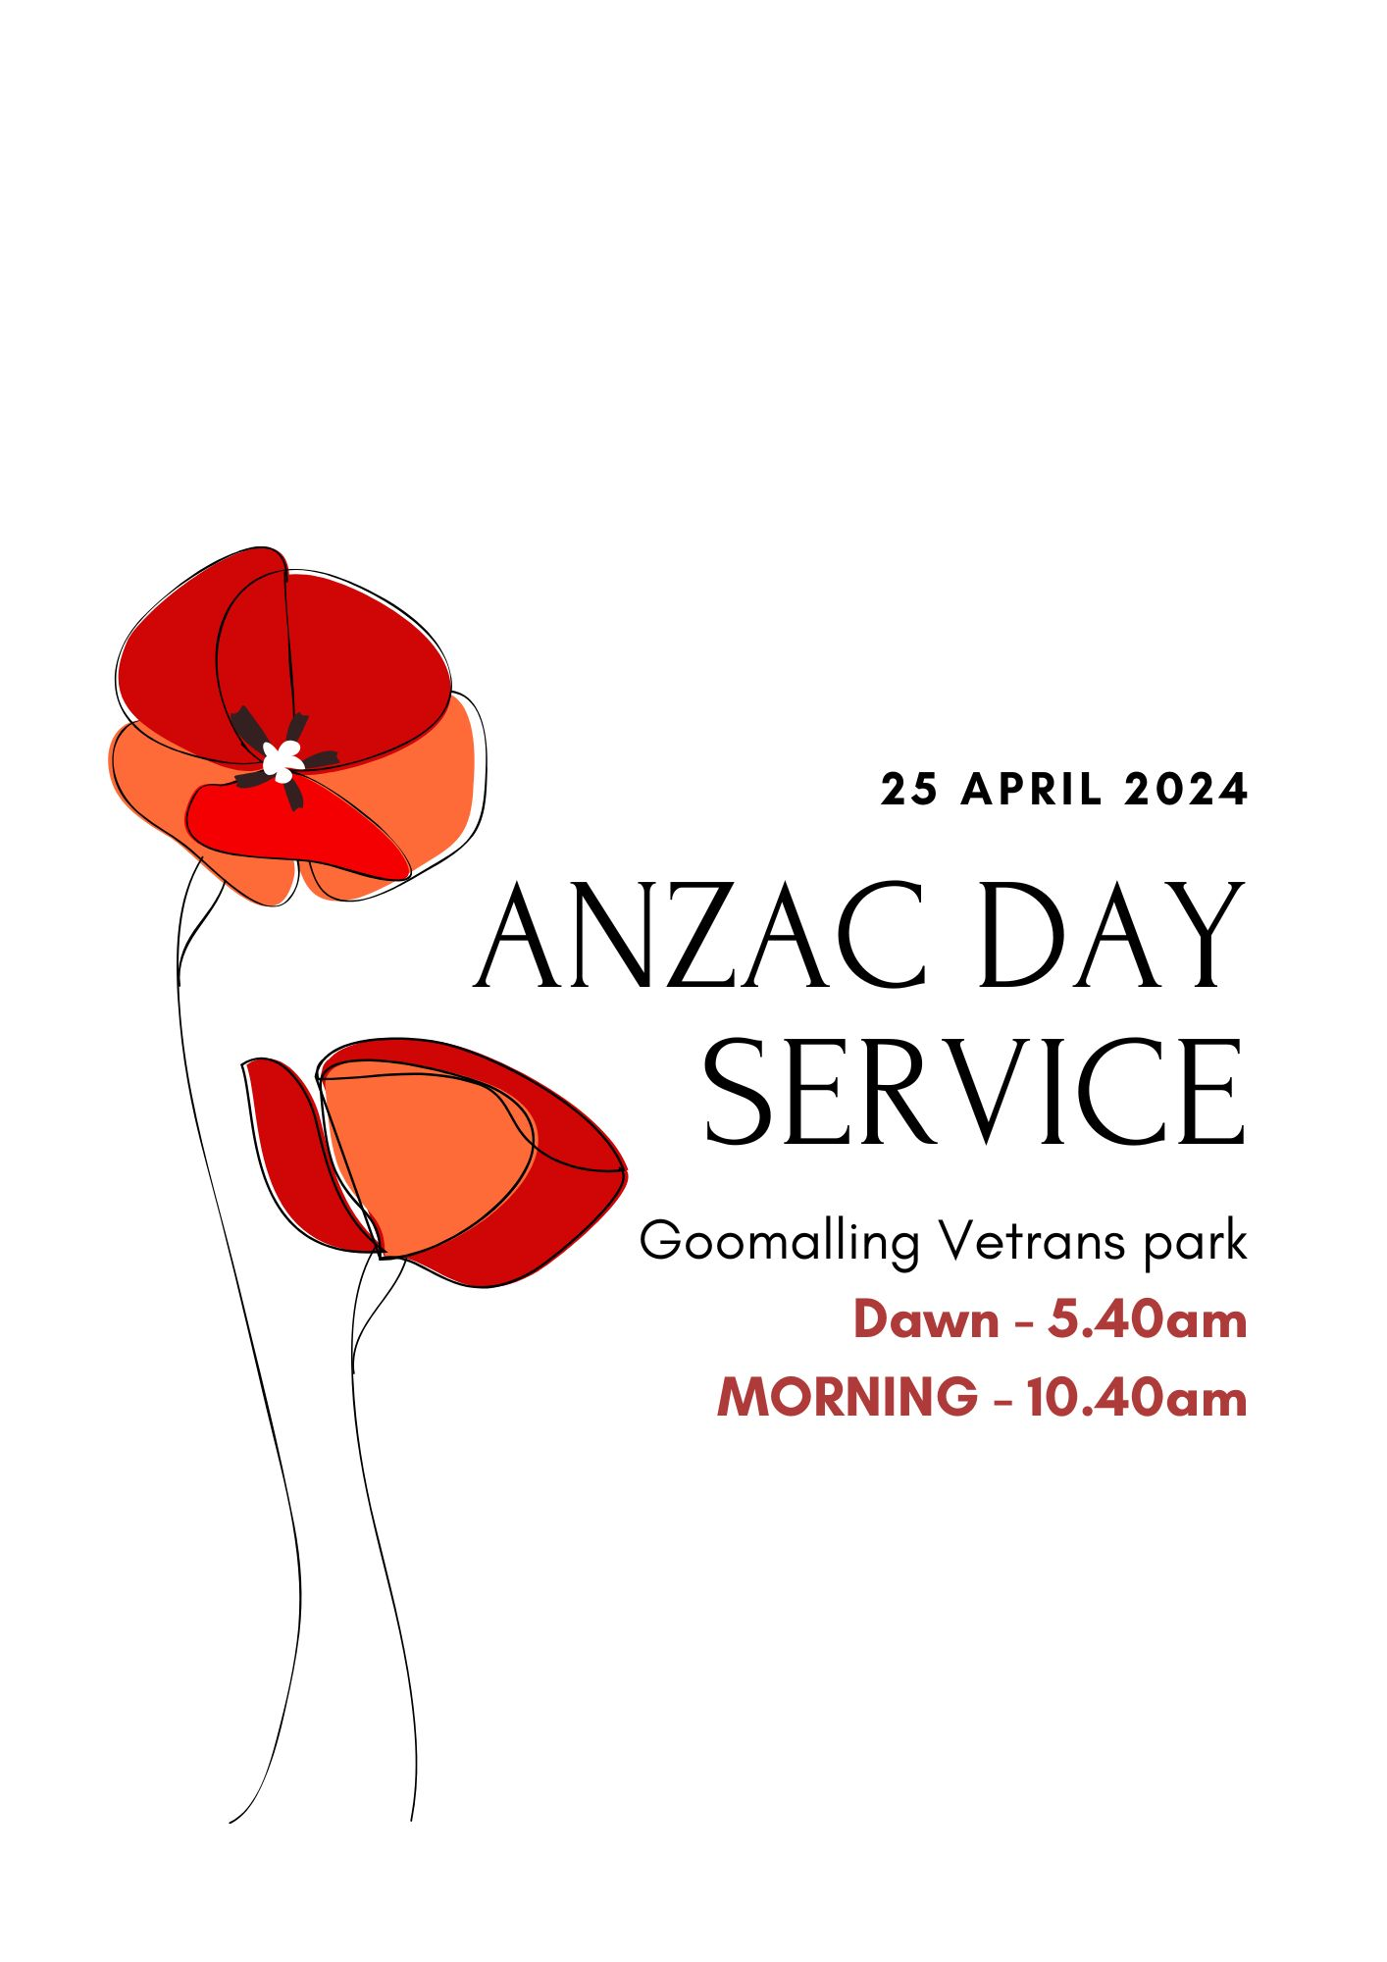

MORE INFO TO COME

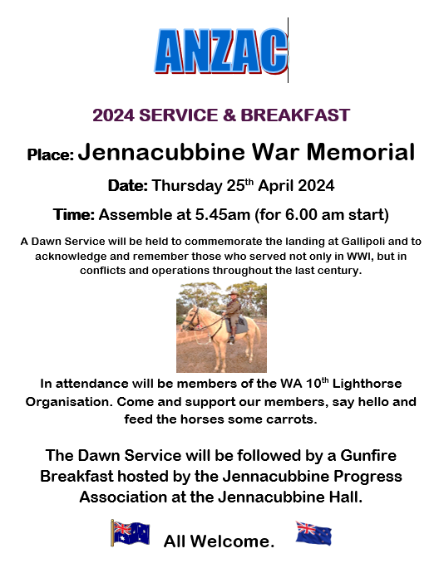

# 

# Dates for your diary

|  |  |
| --- | --- |
| 2024 | |
| MARCH |  |
| Mon 04 Mar | Labour Day Public Holiday |
| Thu 07 Mar | Driving Tests – Bookings Required |
| Wed 20 Mar | Ordinary Council Meeting |
| Thu 29 Mar | Shire Closes at 12 noon |
| Fri 29 Mar | Good Friday Public Holiday |
| APRIL | **Djeran Season commences (Nyoongar Calendar)** |
| Mon 01 Apr | Easter Monday Public Holiday |
| Wed 17 Apr | Ordinary Council Meeting |
| Thu 25 Apr | Anzac Day Public Holiday |
| Fri 26 Apr | Shire Closed |
| MAY |  |
| Wed 15 May | Ordinary Council Meeting |
| JUNE | **Makuru Season commences (Nyoongar Calendar)** |
| Mon 03 Jun | Western Australia Day Public Holiday |
| Wed 19 Jun | Ordinary Council Meeting |
| JULY |  |
| Wed 17 Jul | Ordinary Council Meeting |
| AUGUST | **DJilba Season commences (Nyoongar Calendar)** |
| Wed 21 Aug | Ordinary Council Meeting |
| SEPTEMBER |  |
| Wed 18 Sep | Ordinary Council Meeting |
| Mon 23 Sep | Kings Birthday Public Holiday |
| OCTOBER | **Kambarang Season commences (Nyoongar Calendar)** |
| Wed 16 Oct | Ordinary Council Meeting |
| NOVEMBER |  |
| Wed 20 Nov | Ordinary Council Meeting |
| DECEMBER | **Birak Season commences (Nyoongar Calendar)** |
| Wed 18 Dec | Ordinary Council Meeting |
| Wed 25 Dec | Christmas Day Public Holiday |
| Thu 26 Dec | Boxing Day Public Holiday |

32 Quinlan Street Goomalling | PO Box 118

**T**: 9629 1101 **F**: 9629 1017   
**E**: [goshire@goomalling.wa.gov.au](mailto:goshire@goomalling.wa.gov.au)

[www.goomalling.wa.gov.au](http://www.goomalling.wa.gov.au) | [www.visitgoomalling.com.au](http://www.visitgoomalling.com.au)

Open Monday-Friday 8.30am-4.00pm

Facebook.com/Goomalling Shire