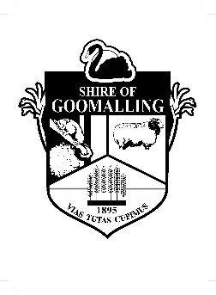**SHIRE OF GOOMALLING**

Office Address: 32 Quinlan Street, Goomalling

Postal Address: PO Box 118, Goomalling WA 6460

Telephone: (08) 9629 1101 Email: goshire@goomalling.wa.gov.au

________________________________________________________________________________________________

**REQUEST FOR BOND RETURN FORM**

This form is to ensure account and personal information is correct when processing bond refunds.

Bonds can only be refunded if gym cards are returned, bonds are forfeit if cards are not returned.

**MEMBER DETAILS**

|  |  |
| --- | --- |
| Full name |  |
| Residential address |  |
| Postal Address |  |
| Phone |  |
| Email |  |

**PAYMENT INFORMATION**

|  |  |
| --- | --- |
| **Method** | |
| cheque (sent to the address above) EFT | |
| **Electronic Funds transfer details (if applicable)** | |
| Account name |  |
| BSB |  |
| Account Number |  |

By signing this form I confirm my information is true and correct, that I no longer require gym membership (have returned my card) and authorise Shire of Goomalling to extract my bond from trust and return it to me via payment information above.

**SIGNATURE: DATE:**

|  |  |  |  |
| --- | --- | --- | --- |
| **OFFICE USE ONLY** | | | |
| Amount |  | Payment no. |  |
| Trust receipt no. |  | Staff signature |  |
| card updated on SALTO | | | |