

SHIRE OF GOOMALLING

REQUEST FOR QUOTATION

Request for Quotation | Bushfire Mitigation Services
Deadline | 12:00pm, 26 July 2024

The Shire of Goomalling (the Shire) is seeking written quotations from Respondents for specific fixed price bushfire mitigation treatments as part of the delivery of bushfire mitigation works throughout the Shire.
Quote Submission
• Deadline for submission of quotes is at 12:00pm Friday 26th July 2024
• Quotes to be submitted electronically via email to goshire@goomalling.wa.gov.au and include the completed price per treatment identified in Annexure 1.
• Queries to be directed in writing to Rob Koch, Community Emergency Services Manager cesm@toodyay.wa.gov.au
Project Background and Objectives
The Shire has been successful in securing funding for the delivery of mitigation works to protect assets and manage areas of significant risk from wildfire. The Shire of Goomalling has identified 12 locations of high to extreme risk that require mitigation treatment in the form chemical application, slashing and bridge assets vegetation management totalling 58 hectares. The objective of this project is to effectively manage the identified bushfire risk as outlined in the Shire of Goomalling Bushfire Risk Management Plan. The project will be delivered over a period of approximately August 2024, concluding November 2024, subject to weather conditions and operator availability.
Equipment Criteria
All plant should be in good working condition, well maintained and fully insured. All plant shall meet the relevant safety requirements stipulated by legislation but should specifically meet the following:
• Fully cleaned down before arrival at each site.
• Serviceable minimum 9kg fire extinguisher
• Serviceable UHF Radio
• Rollover Protective Structures (ROPS) and Falling Object Protective Structures (FOPS) that meet relevant Australian Standards
• Operational amber beacon with 360-degree visibility
• Reverse lights with audible warning
If the plant or equipment is inoperative or not fit for purpose due to breakdown, safety reasons or otherwise, the Shire may stand down the pant through a notice to the contractor or their representative. During any stand down time, the hire period will be terminated, and the principal will incur no costs.
Please note: Some treatments are not suited to vehicular plant and require hand operated power tools.

Project Schedule
Milestone Date Submission of written quotations 12:00 26th July 2024.
Contract awarded by 02nd August 2024
Completion of works as per required to meet Treatment Objective (specification) set in Annexure 1, and no later than the completion date of Annexure 1 for each treatment. If Respondents are unable to meet the above completion date, a proposed completion date shall be noted in their quote submission.
Respondents to Note
• This procurement process is not a tender process as is defined, interpreted, and represented by Local Government Regulation (Functions and General) 1996. The estimate value of engagement via this procurement being less than $249,999, this procurement process is governed by the internal Purchasing Policy of the Shire of Goomalling, which is available at Shire of Goomalling website (www.goomalling.wa.gov.au)
• Quotes and documents submitted will become the property of the Shire;
• The respondent is required to provide sufficient information so that all the above elements can be evaluated. Respondent to note that the Shire of Goomalling will not make any assumptions during quote assessment, and hence it is the sole responsibility of the respondent to provide the complete information in their quote, which will enable the Shire to evaluate the quote;
• The Shire, at sole discretion, may strategically split the Project Deliverables and Scope of Work, among multiple Contractors;
• The evaluation of submissions (quotes) may compose an evaluation panel representing user’s groups, stakeholders or/and internal/external consultants/experts;
• The Shire reserves the right to withdraw or suspend this procurement/ quotation process at any stage, at its sole discretion. The Shire is not liable to any claim or payment, against any expenditure, direct or indirect, incurred by the respondent, during preparation of quotation;
• The delay in receipt of a quote is not the responsibility of the Shire and late quotation submissions may not be accepted;
• The respondent will be sent a confirmation email after receipt of the quote;
• The quote should be valid for at least 60 days from the last date of submission of quote as mentioned in this document;
• By submitting a quote against this procurement process, the respondent accepts the terms of this process;
• This procurement process does not in any form represent a process contract;
• In the event that multiple quotes are received from the respondent, only the last and the latest one will be valid for the representation in this procurement process;
• Electronic submissions must not exceed 10 MB, with Microsoft Word and PDF documents preferable;
- IMPORTANT: Chemical Works treatment type treatments: The respondent should demonstrate their ability to substitute chemical application with slashing (either whole or in part), should chemical application windows be missed, or application be ineffective. Respondents offering slashing only services may provide treatment quotes for a slashing only service, however this must be notated in the response.
Shire of Goomalling Contact
Rob Koch 0458 042 104, cesm@toodyay.wa.gov.au
Form of Contract
The Shire of Goomalling may enter a contract with the successful respondent by issuing following documents which will become part of the contract:
• Purchase Order; and
• ‘Standard General Conditions of Contract (GCC) for Supply of Goods and Services under Purchase Order’
Annexure 1 Treatment Schedule Details

Shire of Goomalling MAF GP 2024/25 Round 1
NB: Subject Treatment Extents are in Red Outline.
Treatment ID | Treatment Type | Treatment Objective | Treatment Area (ha) | Treatment Length (km) | Completed Before | Quoted Treatment Cost (ex GST) | Notes
27892 | Mechanical Works | 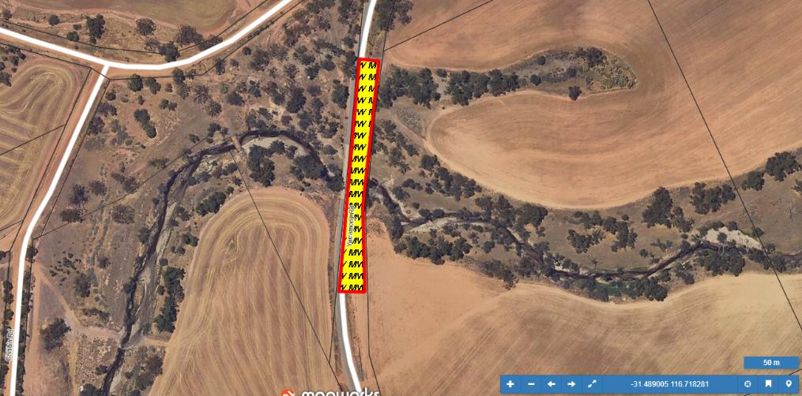  27892/29383/GOOGML0376 - LG Bridge 4189 Yarramony - Provide low fuel buffer (<2t/ha) to timber bridge asset, by way of slashing, herbicide application and pruning vegetation within 10m of bridge (or property line, whichever is closer). Provide fire support if fuels are cured during works. | 0.365 | 0.464 | 30/11/2024
27891 | Mechanical Works | 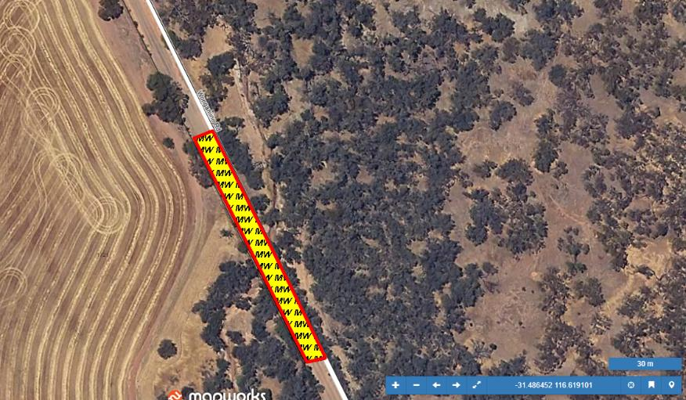  27891/29390/GOOGML0380 - LG Bridge 4205 Wongamine - Provide low fuel buffer (<2t/ha) to timber bridge asset, by way of slashing, herbicide application and pruning vegetation within 10m of bridge (or property line, whichever is closer). Provide fire support if fuels are cured during works. | 0.082 | 0.222 | 30/11/2024
27890 | Mechanical Works | 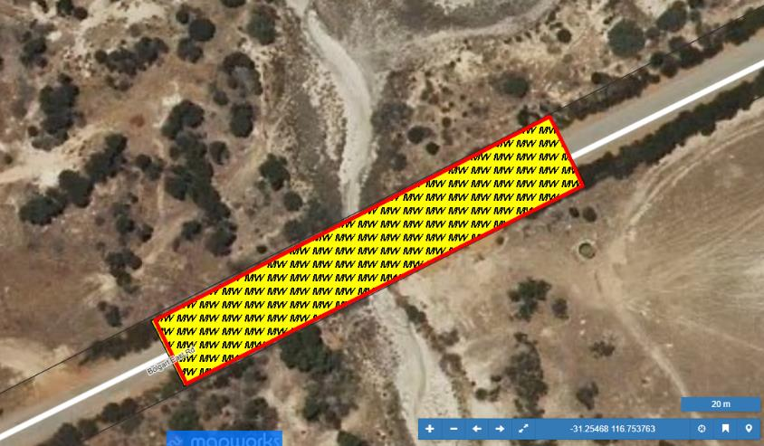  25890/29389/GOOGML0379 - LG Bridge 4202 Bolgart East - Provide low fuel buffer (<2t/ha) to timber bridge asset, by way of slashing, herbicide application and pruning vegetation within 10m of bridge (or property line, whichever is closer). Provide fire support if fuels are cured during works. | 0.209 | 0.261 | 30/11/2024
27889 | Mechanical Works | 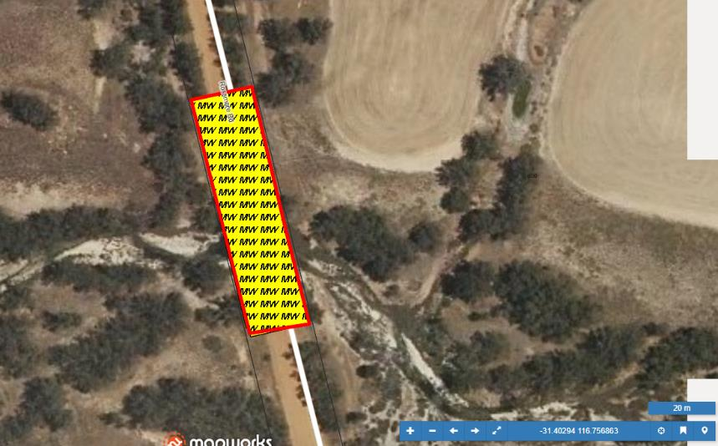  27889/29387/GOOGML0378 - LG Bridge 4197A Rossmore - Provide low fuel buffer (<2t/ha) to timber bridge asset, by way of slashing, herbicide application and pruning vegetation within 10m of bridge (or property line, whichever is closer). Provide fire support if fuels are cured during works. | 0.131 | 0.181 | 30/11/2024
27888 | Mechanical Works | 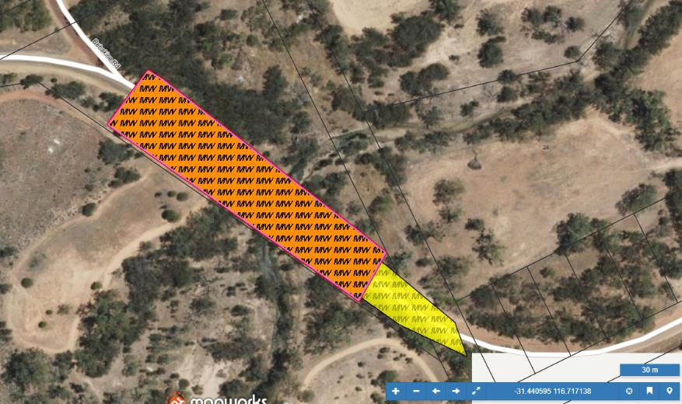  27888/9384/GOOGML0377 - LG Bridge 4196 Tyndall - Provide low fuel buffer (<2t/ha) to timber bridge asset, by way of slashing, herbicide application and pruning vegetation within 10m of bridge (or property line, whichever is closer). Provide fire support if fuels are cured during works. | 0.473 | 0.367 | 30/11/2024
27887 | Chemical Works | 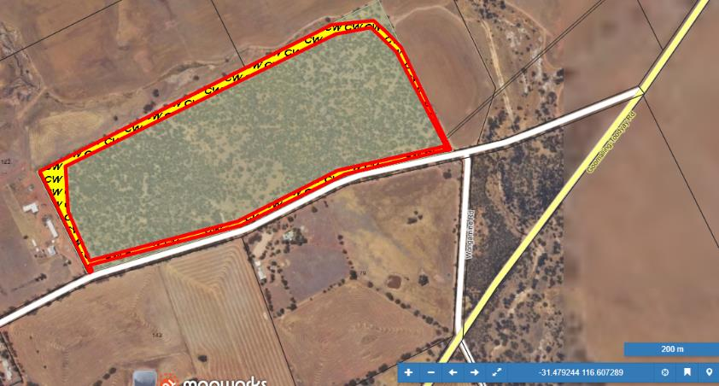  27887/27242/GOOGML0102 - Hughes Road Reserve - Manage annual grassy weeds/fire access track regrowth, on and 3m adjacent to track to less than 2t/ha by application of post and pre-emergent herbicide using vehicle. Include clear area in northwest corner of reserve. This site suitable up to small 4WD truck. Application must occur prior to weed seed development. Vehicle(s) to be washed down prior to arrival and prior to departure from site to protect against soil or seed transfer between sites. | 2.9 | 4.131 | 30/11/2024
27885 | Chemical Works | 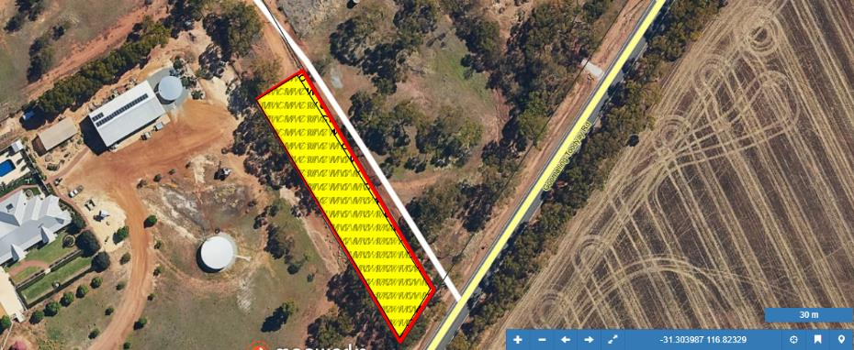  27885/27412/GOOGML0173 - End of Maher Street - Manage annual grassy weeds to less than 2t/ha by application of monocot specific herbicide (with wetting agent), utilising small vehicle (quad bike or ATV). Some manual (hand spraying) may be required. Application must occur prior to weed seed development. Application to be excluded from naturally occurring low fuel area (i.e. those areas where the environment is naturally suppressing majority of weeds). Native species seedlings (i.e. Acacia/Eucalypt) are to be protected from damage (avoided by applying vehicle). Vehicle(s) to be washed down prior to arrival and prior to departure from site to protect against soil or seed transfer between sites. | 0.166 | 0.22 | 30/11/2024
27884 | Chemical Works | 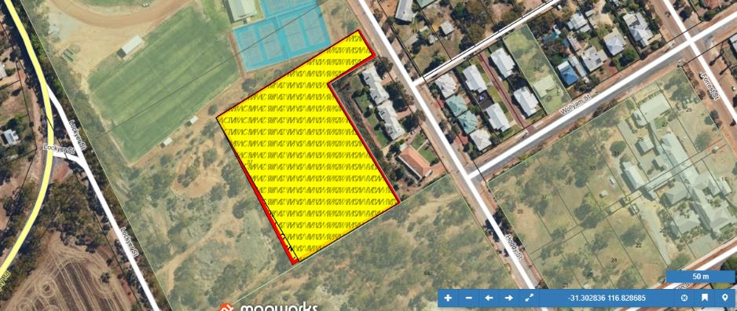  27884/27455/GOOGML0182 - Rear of Aged Care Hoddy Street - Manage annual grassy weeds to less than 2t/ha by application of monocot specific herbicide (with wetting agent), utilising small vehicle (quad bike or ATV). Some manual (hand spraying) may be required. Application must occur prior to weed seed development. Application to be excluded from naturally occurring low fuel area (i.e. those areas where the environment is naturally suppressing majority of weeds). Native species seedlings (i.e. Acacia/Eucalypt) are to be protected from damage (avoided by applying vehicle). Vehicle(s) to be washed down prior to arrival and prior to departure from site to protect against soil or seed transfer between sites. | 1.095 | 0.49 | 30/11/2024
27883 | Chemical Works | 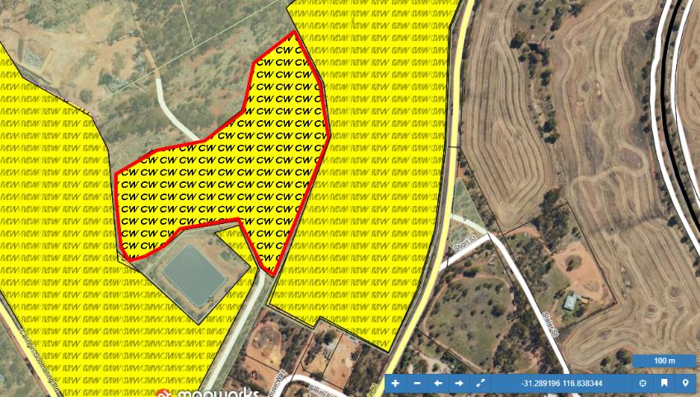  27883/27572/GOOGML0207 - Tip Entry Reserve Block - Manage annual grassy weeds to less than 2t/ha by application of herbicide using vehicle (site suitable for up to small 4WD truck). Application must occur prior to weed seed development. Vehicle(s) to be washed down prior to arrival and prior to departure from site to protect against soil or seed transfer between sites. | 6.259 | 1.229 | 30/11/2024
27881 | Chemical Works | 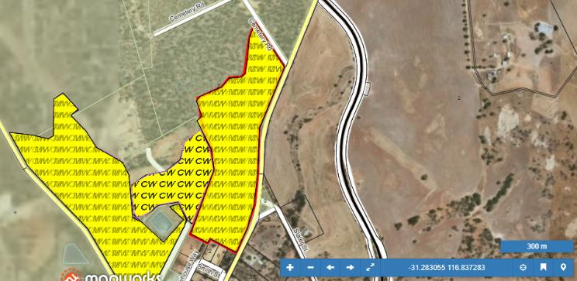  27881/27523/GOOGML0204 - Northam Pithara Reserve Block - Manage annual grassy weeds to less than 2t/ha by application of monocot specific herbicide (with wetting agent), utilising small vehicle (quad bike or ATV). Some manual (hand spraying) may be required. Native species seedlings (i.e. Acacia/Eucalypt) are to be protected from damage (avoided by applying vehicle). Include additional non-selective post and pre emergent herbicide application on and 3m adjacent to fire access tracks. Application must occur prior to weed seed development. Application to be excluded from naturally occurring low fuel area (i.e. those areas where the environment is naturally suppressing majority of weeds). Vehicle(s) to be washed down prior to arrival and prior to departure from site to protect against soil or seed transfer between sites. | 16.879 | 2.256 | 30/11/2024
27880 | Chemical Works | 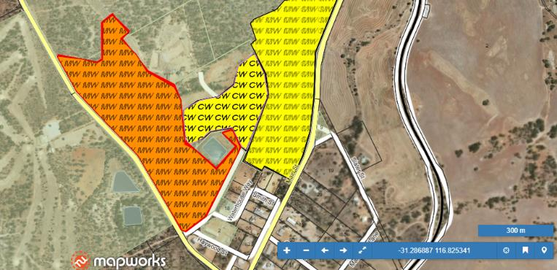  27880/27578/GOOGML0211 - Callingiri Goomalling Road Reserve - Manage annual grassy weeds to less than 2t/ha by application of monocot specific herbicide (with wetting agent), utilising small vehicle (quad bike or ATV). Some manual (hand spraying) may be required. Native species seedlings (i.e. Acacia/Eucalypt) are to be protected from damage (avoided by applying vehicle). Include additional non-selective post and pre emergent herbicide application on and 3m adjacent to fire access tracks. Application must occur prior to weed seed development. Application to be excluded from naturally occurring low fuel area (i.e. those areas where the environment is naturally suppressing majority of weeds). Vehicle(s) to be washed down prior to arrival and prior to departure from site to protect against soil or seed transfer between sites. | 19.686 | 2.769 | 30/11/2024
27887 | Chemical Works | 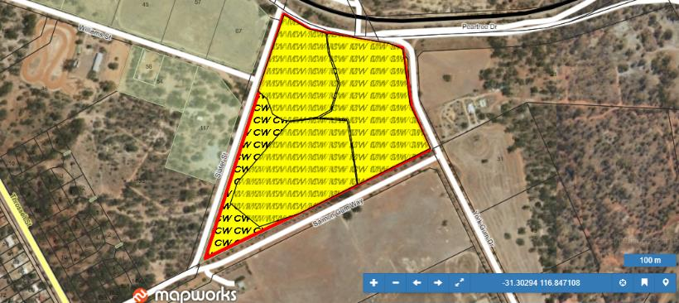  27887/27294/GOOGML0128 - Old Tip Reserve - Manage annual grassy weeds to less than 2t/ha by application of monocot specific herbicide (with wetting agent), utilising small vehicle (quad bike or ATV). Some manual (hand spraying) may be required. Native species seedlings (i.e. Acacia/Eucalypt) are to be protected from damage (avoided by applying vehicle). Include additional non-selective post and pre emergent herbicide application on and 3m adjacent to fire access tracks. Application must occur prior to weed seed development. Application to be excluded from naturally occurring low fuel area (i.e. those areas where the environment is naturally suppressing majority of weeds). Vehicle(s) to be washed down prior to arrival and prior to departure from site to protect against soil or seed transfer between sites. | 10.08 | 1.4 | 30/11/2024

